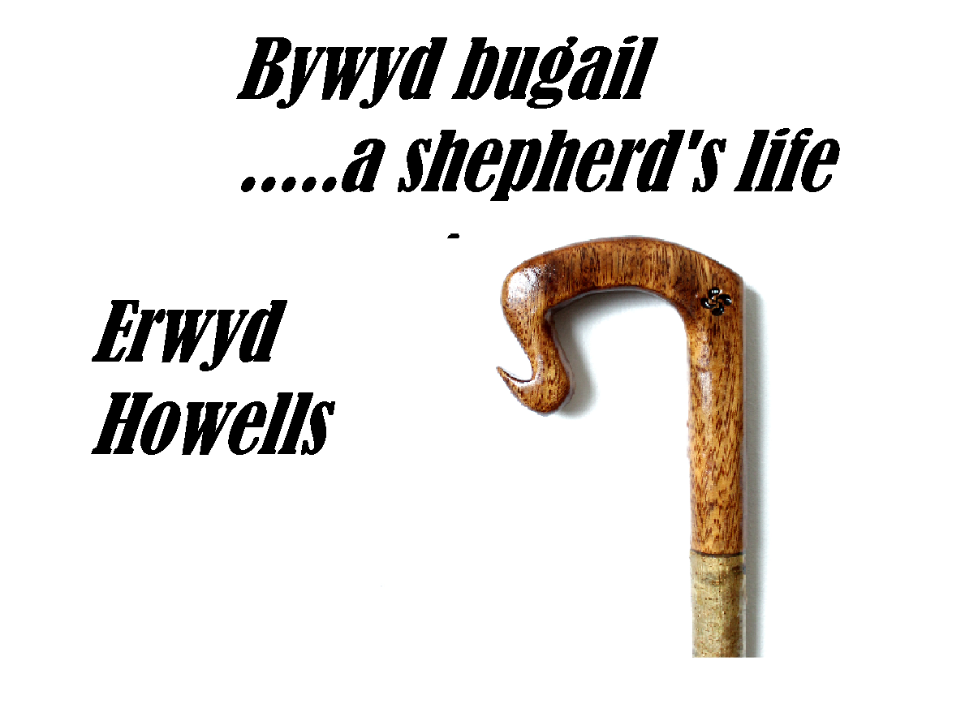
Cymdeithas Hanes Blaenpennal,
Cyfarfod 14eg Tachwedd, 7.30 yh
Ystafell Hir, Capel Penial ,Blaenpennal
Tâl mynediad £2 i bawb nad sy’n aelod.

Blaenpennal Local History Society
Meeting, 14th November, 7.30pm
The Long Room, Penial Chapel, Blaenpennal
Entry fee £2 for Non members of Society.

